Book Bulletin No. 01 & catalogue - February 2021

Welcome to the first in a series of bulletins about books for your collection or for treasured gifts.
Funds raised from these sales accrue to:
The Botanical Society of South Africa : KZN Coastal Branch funds
The Wally Menne Memorial Book Fund - for the sponsorship of botanical books to deserving recipients
The Botanical Education Trust supporting conservation research/projects
--------------------------------------------------------------------------------------------------------------------------
At last! The long-awaited 3rd reprint of this essential field guide is here!

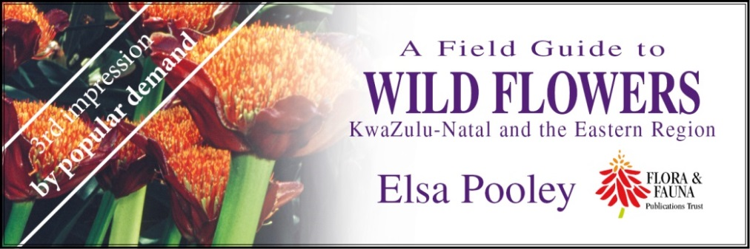

This field guide has been out of print for nearly 3 years. It has been a best seller since its release in 1998, providing a fully illustrated guide to over 2000 species of indigenous flowering plants in much of the eastern summer rainfall region. Soft cover. R425.00 + R70.00 courier.

WHO USES THIS BOOK?
Wildlife enthusiasts, indigenous gardeners, tour guides, students from school to universities, researchers and environmental practitioners
It is a user-friendly field guide and an outstanding reference work with 632 pages, over 2000 species and 2450 photographs
The book includes:
*colour coding
*ecological and gardening notes
*common names in English, Afrikaans, South Sotho, Swazi, Thonga, Xhosa and Zulu
*Maps cover a large part of the summer rainfall region from East London in the Eastern Cape to southern Mozambique border, inland to eastern Free State, Gauteng, Northern Province and Mpumalanga including Lesotho and Swaziland.
IN SHORT, THE ESSENTIAL REFERENCE BOOK FOR EVERYONE INTERESTED IN THE REGION’S PLANTS!

______________________________________________________________________________

Member’s Book Review…

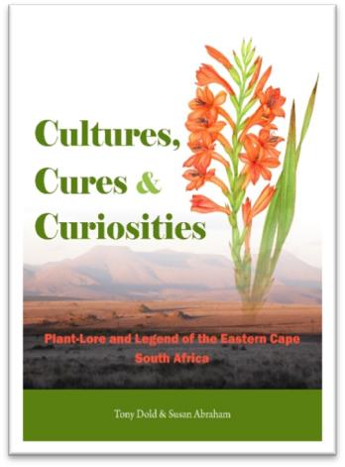
Cultures, Cures and Curiosities. Plant-lore and Legend of the Eastern Cape, South Africa
by Tony Dold and Susan Abraham Published by Botanical Society of South Africa (2019).
Soft cover. 382 pages.
Price: R390.00 incl VAT excl. R80.00 postage

Member William Collingwood’s Book review of Cultures, Cures and Curiosities. Plant-lore and Legend of the Eastern Cape, South Africa by Tony Dold and Susan Abraham:

‘It is certainly one of my favourite plant books. It’s not a field guide but it is so informative. The background of early pioneer botanists is really interesting and the usage of their illustrations of the plants is so good to see.
The authors have chosen forty plants and then give the accurate use of these by traditional medicine healers as well as the early trekkers’ use of these and any modern western usage.
It’s this information that I found fascinating. I have always enjoyed walking trails at Mfolozi, Umfolozi and Ndumu - the rangers there are always so knowledgeable about traditional usage of the plants we see on trail.
To have this book written in such detail makes one realise how much there is still to learn.’

Other necessities for your collection… or to start someone else off!
Bring Nature Back to your Garden, Northern & Eastern edition, Charles & Julia Botha. 2010. Published by the Flora & Fauna Publications Trust. R165 + R70 postage. Soft cover. 254 pages.
Some colour illustrations by well-known artists.

Winner of a University of KwaZulu-Natal book prize.

‘…packed with useful and interesting information which makes easy reading….. ‘ SUNDAY TIMES

‘...enchanting in its refreshing approach to gardening.’
FARMER’S WEEKLY
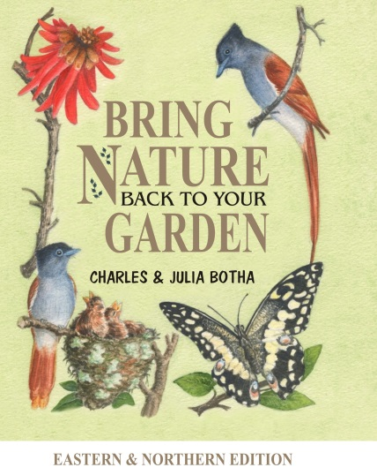

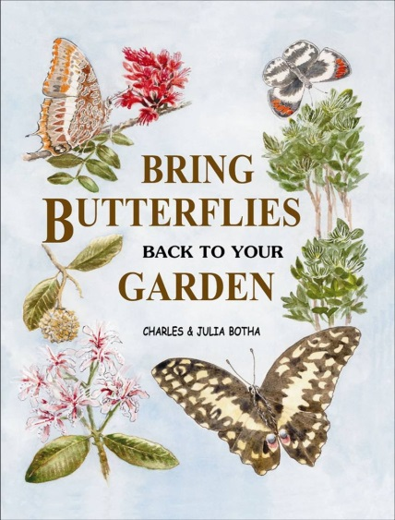
Bring Butterflies Back to your Garden, Charles & Julia Botha. 2006.
Published by BotSoc KZN Coastal Branch.
R145 + R70 postage. Some colour paintings. Soft cover. 254 pages.
‘Very impressive, an encyclopaedia of butterfly gardening but lighthearted and full of humour.’ DR EUGENE MOLL
Chapters include: Creating a Butterfly Habitat, Indigenous Larval Food-plants, Who Eats What, Butterflies in Trouble.

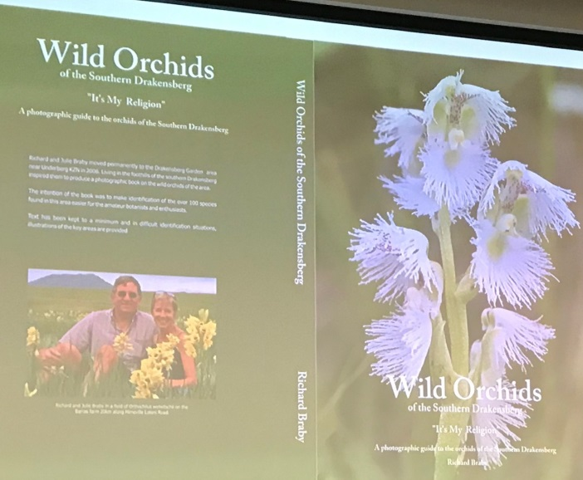
Wild Orchids of the Southern Drakensberg – ‘It’s My Religion’
Richard Braby. 2019.

Soft cover, 218 pages. R450 + R80 postage.

Over 100 variations of orchids with two A4 pages of photos dedicated to each. Beautiful photographs illustrate the features of the orchids, keeping botanical terminology to a minimum.

Great to have with you on ‘Berg trips.

Photo: Di Higginson Keath

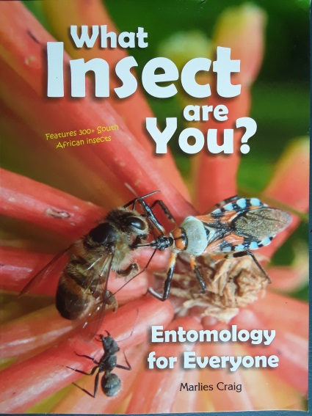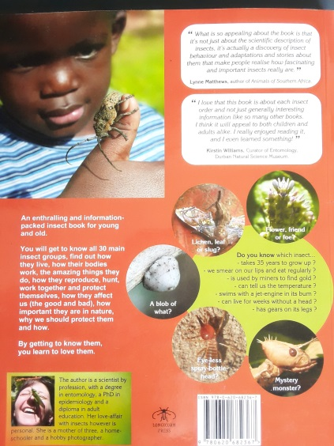
What Insect Are You? Entomology for Everyone,
by Marlies Craig. 2016.

Soft cover, 160 pages.
R385 + R80 postage.

Features 300+ South African insects.

An enthralling and information packed insect book for young and old.

PlantLife back copies … Spotlight on Volume 35

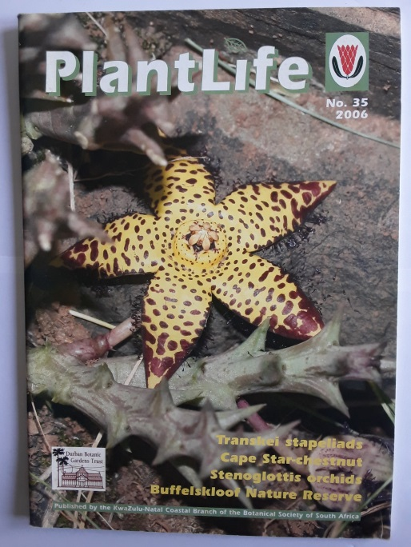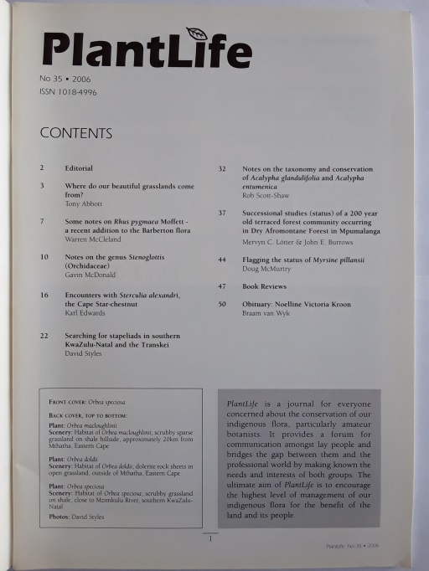
PlantLife journal, Vol 35, 2006.
Published by BotSoc KZN Coastal Branch & The Durban Botanic Gardens Trust.
R20 + R12 postage.

Includes book reviews of Stapeliads of Southern Africa and Madagascar, by P V Bruyns; Grass Aloes in the South Africa veld, by C Craib; and Growing Rare Plants, by Geoff Nichols.

Indigenous Gardening Handbook 2014 : Gardening Naturally

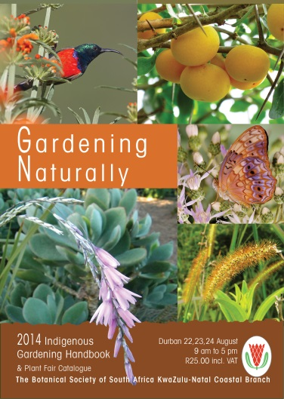
Foreword | Janet Longman
Hot & Dry? Choose succulents | Elsa Pooley
Shady slopes solutions | Jenny Dean
At your service - frogs & toads saving your skin | Dr Jeanne Tarrant
Three Tree Combo | Sally Johnson
Most effective pesticides | Charles & Julia Botha
Mulching with Groundcovers | Lindsay Gray
Black Gold - leaves as natural fertiliser | Jane Troughton
Back to the Wild | Andrea Abbott
CRASSULACEAE- One stop butterfly shop | Steve Woodhall
Designing complete Habitats | Anno Torr
CREW: How Gardeners can help threatened plant species | Suvarna Parbhoo
Plant catalogue
Indigenous nurseries, landscapers & consultants
Alien invader plant contractors

Published by BotSoc KZN Coastal Branch.
Price: R10 + R10 postage

Book Bazaar: ….Pre-loved books for sale… BotSoc members receive 10% discount on book prices!

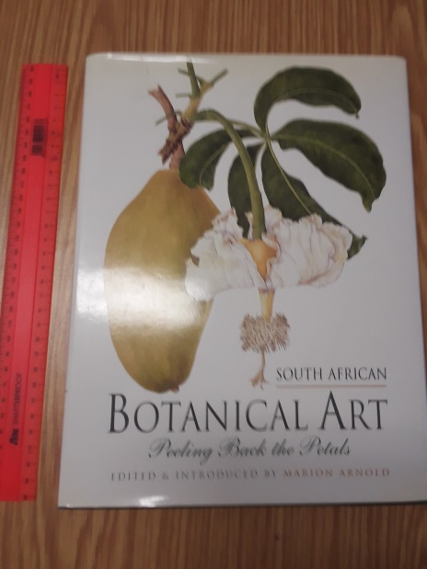
South African Botanical Art – Peeling Back the Petals, Marion Arnold, 2001.

Hard cover. 216 pages. Condition: Very good. Price: R800 + R95 postage

Includes contributions by John Rourke, Dee Snijman, John Manning, Peter Goldblatt, and a concise dictionary of South African Botanical Artists by Gillian Condy and John Rourke.

Many beautiful illustrations.

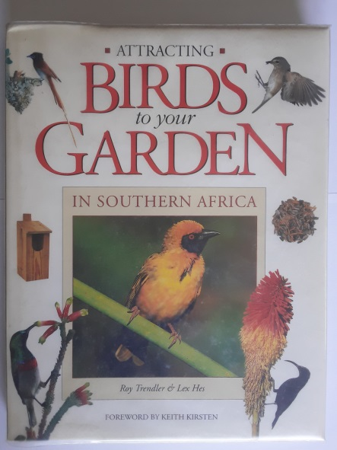
Attracting Birds to your Garden in Southern Africa, Roy Trendler & Lee Hes, 1994. Condition: very good.
Price: R120 + R70 postage
Covered in plastic. Hard cover, 208 pages, more than 400 colour photographs. Chapters include: Planning the garden, Feeding and bird fare, Water in the garden, Nesting, Maintaining the Indigenous garden, Pest control, Directory of garden birds and Table of indigenous plants.

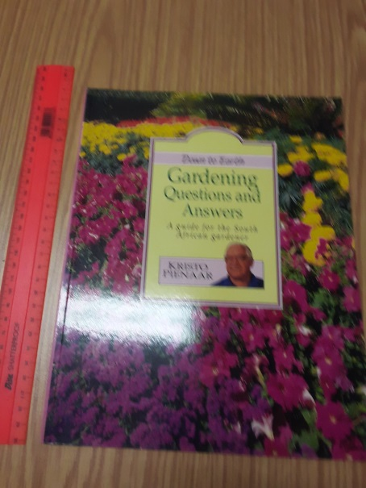
Down to Earth Gardening Questions & Answers – A guide for the South African gardener, Kristo Pienaar. 2003.
Paperback, 64 pages. Condition: Very good. Price: R60 + R60 postage.

Offers solutions to more than 200 questions which are regularly asked by gardeners, based on frequently asked questions on a scientific radio show for 30 years and gardening columns in the press.

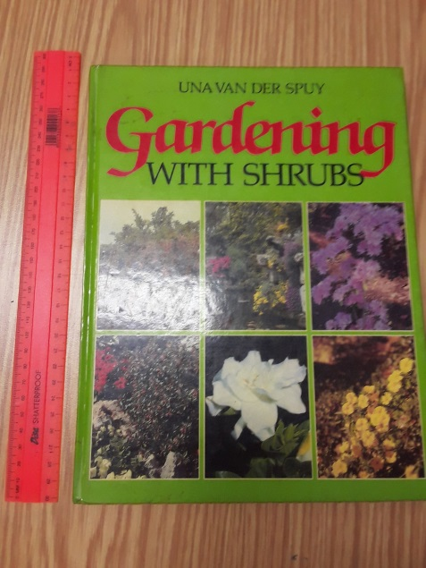

Gardening with Shrubs – Shrubs of the World for Gardens in the Southern Hemisphere, Una van der Spuy. 1986. Hard cover. 192 pages.
Condition: Fair. Price: R60 + R65 postage.
Guide to more than 700 varieties of shrubs from all around the world, including several indigenous species. Selection guides using various criteria. Species guide descriptions and cultivation advice.

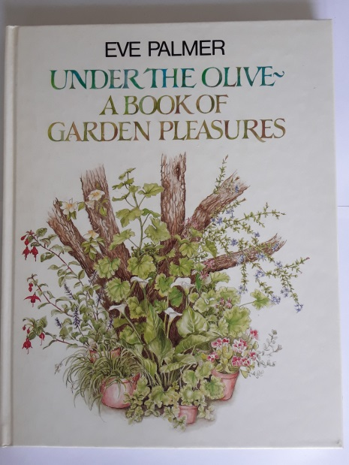
Under The Olive – A Book of Garden Pleasures, Eve Palmer, 1989. Hardcover, 127 pages, very good condition, 1st edition,1st impression. Price: R130 +R70 postage.
The author pays personal tribute to the (mostly indigenous) trees and smaller plants of her garden and the pleasures they have brought her: shade and shelter, shape, foliage and bark, flowers and fruit, colour, scent, food; birds and butterflies. This account of her “holds upon happiness” is interwoven with a wealth of anecdotes, reminiscences, sketches of people and places, items of folklore, and her own acute observations. Delightful, heart-warming, yet informative. Lovely illustrations by Brenda Clarke.

Trees of Natal, Eugene Moll, 1981.
Paperback, 567 pages, Conditions: Fair to Good. Black-and-white line drawings. Price: R100.00 + R70 postage.
This classic is a still extremely useful identification guide to our trees using leaf appearance & leaf arrangements plus arrows showing the most important ID points.
At the 2019 plant fair a visiting overseas researcher chose this book for its key which he felt would most easily help him identify the trees in our forests.
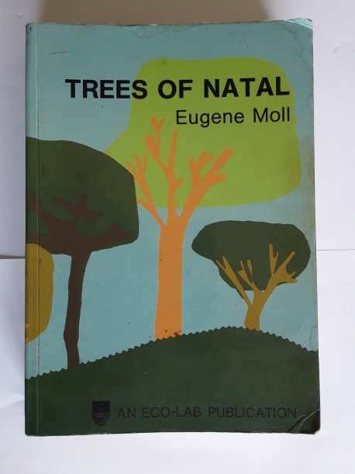

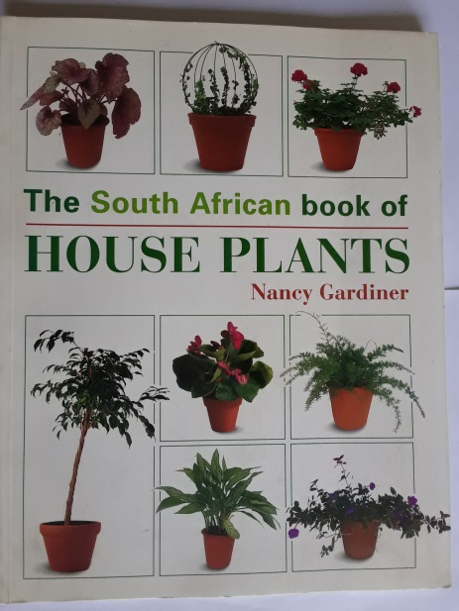
The South African book of House Plants, Nancy Gardiner, 1998.
Soft cover, 112 pages, very good condition.

Price: R80 + R65 postage.

Chapters include: Caring for your house plants, Decorating with house plants (including a novel fridge magnet pot plant idea), Directory of house plants (giving names to those you never could name). Although not many SA species, the attractive photos will inspire you to try local equivalents.

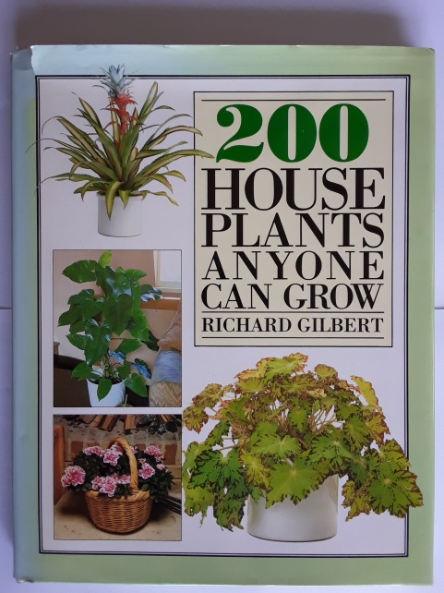
200 House Plants Anyone Can Grow, Richard Gilbert. 1988. Hard cover, 144 pages. Very good condition.
Price: R90 + R65 postage.
Includes an A-Z plant guide, and decorating know how and plant care.
A couple of unexpected KZN species made the cut in this originally British book. As with the previous book, the photos will inspire you to try similar-looking South African species.

____________________________________________________________
Not just books

T-shirts too…

‘SA Floral Beauties’ high quality BotSoc Branch T-shirts make great gifts!

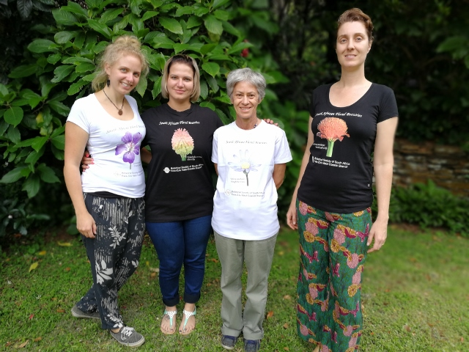

Pic 1 shows (from left to right): Sophia (Geranium incanum / Carpet Geranium), Nicola (Kniphofia uvaria / Fire Lily ), Janet (Felicia amelloides / Kingfisher Daisy (blue flower)), Leigh (Scadoxus puniceus / Paintbrush Lily). Nicola and Janet are wearing the Male-style T-shirts while Sophia and Leigh show the Ladies’ style. Black or White T-shirts – depending on stocks left.

Price: R150.00 each incl. VAT, + R70 postage. Mostly Small & Medium sizes available.

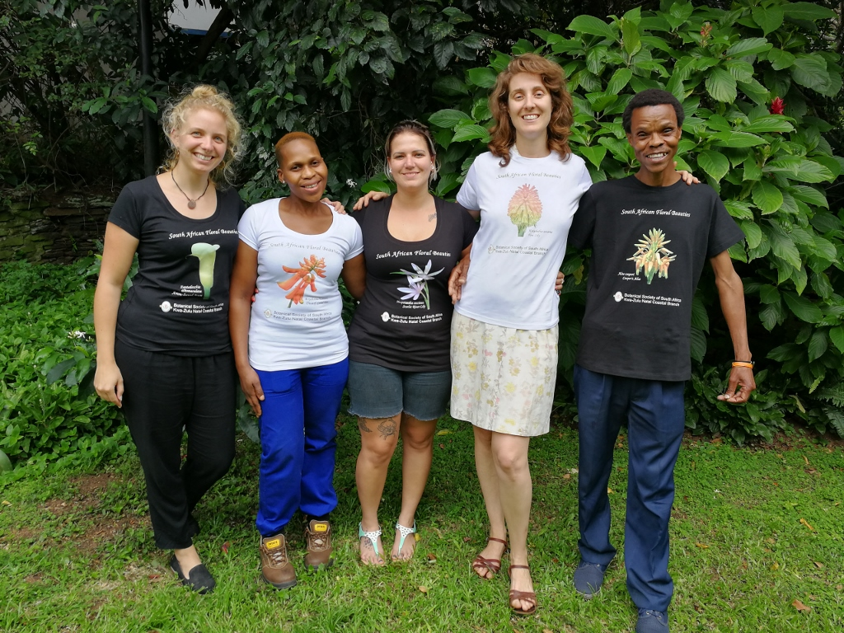
Pic 2 from L to R: Sophia (Zantedeschia aethiopica / Arrow-leaved Arum), Busi (Erythrina humeana / Dwarf Coral Tree), Nicola (Hesperantha coccinea / Scarlet River Lily (pink flower)), Leigh (Kniphofia uvaria / Fire Lily) and Thami (Aloe cooperi / Cooper’s Aloe). Leigh & Thami show the Male-style T-shirts, while the others show the Ladies’ style.

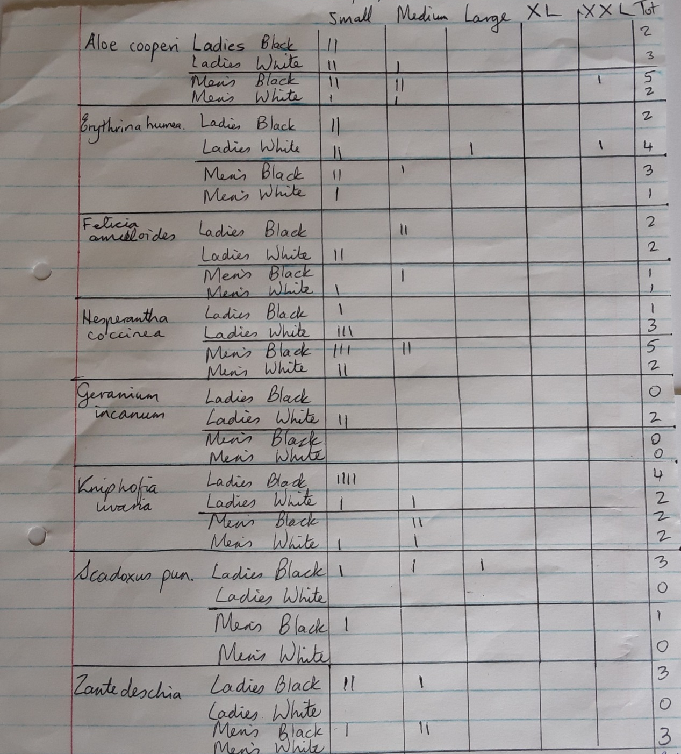
T-shirt stocks available

_______________________________________________________________________________________________

A BotSoc Subscription makes a welcome gift!

Affordable from just R266 p.a. for Regional Senior Membership, R326 for Regional Adult, to R471 for Regional Family, membership includes free entrance into SA’s 10 National Botanical Gardens (max 4 free entries into Kirstenbosch), 4 x free Veld & Flora magazines
p.a., 10% discount from the Botanical Society Kirstenbosch Bookshop and concessions at participating outlets plus the opportunity to participate in local branch events and activities and to network with like-minded people.

Please click the how to join Tab at the top of the KZN Coastal Branch Home page for more details.

_____________________________________________________________________________________
ORDERS
Before paying for any items, please enquire by email to botsoc-kzn@mweb.co.za or tel/WhatsApp/SMS: 0718693693.
On confirmation please pay into the Branch’s bank account (which is different to the account used to pay membership fees). The Branch’s bank account details are: The Botanical Society of SA, Nedbank, Durban North branch, account number 1352029901.
Please email Proof of payment with your confirmed order.

Payment can also be made by PayFast, or by card on Zapper, or by card online through Yoco.

Please see our Home page for the links.

PayFast Yoco




If you would like to pay by Zapper and don’t have it already, you would need to download the Zapper app onto your cellphone from your Play Store and set it up with your card details.

All new items: prices include 15% VAT.

Postage/delivery – by arrangement: Goods can be posted as insured parcels through the Post Office at the given postage costs, or can be sent to your nearest Pep Store for about R15 extra than the P.O. rate, or may be collected from the BotSoc KZN Coastal Branch Office at Durban Botanic Gardens by appointment. Hand delivery at R50 per delivery may be possible within parts of the Durban area.

Botanical Society: KZN COASTAL BRANCH

C/o Durban Botanic Gardens Curator’s Office www.botsoc-kzn.org.za
72 St. Thomas Rd, Berea, Durban 4001-temp closed www.indigenousplantfair.org.za
Tel: c/o 071 869 3693 Mon + Thurs 10:00-16:00 https://plantlifesouthafrica.blogspot.co.za
Email: botsoc-kzn@mweb.co.za Facebook: Botanical Society KZN Coastal Branch
Know, grow, protect and enjoy South Africa’s indigenous plants

